How create branch and folder name in GitHub through gitbash

This documentation was made to demonstrate how to create branch and folder name in GitHub through gitbash. This documentation shows the steps using Windows 10.

Steps to follow to create branch and folder name in GitHub through gitbash

Step 1: Branch
Chameleon GitHub：https://github.com/Chameleon-company
Then select MOP-Code.
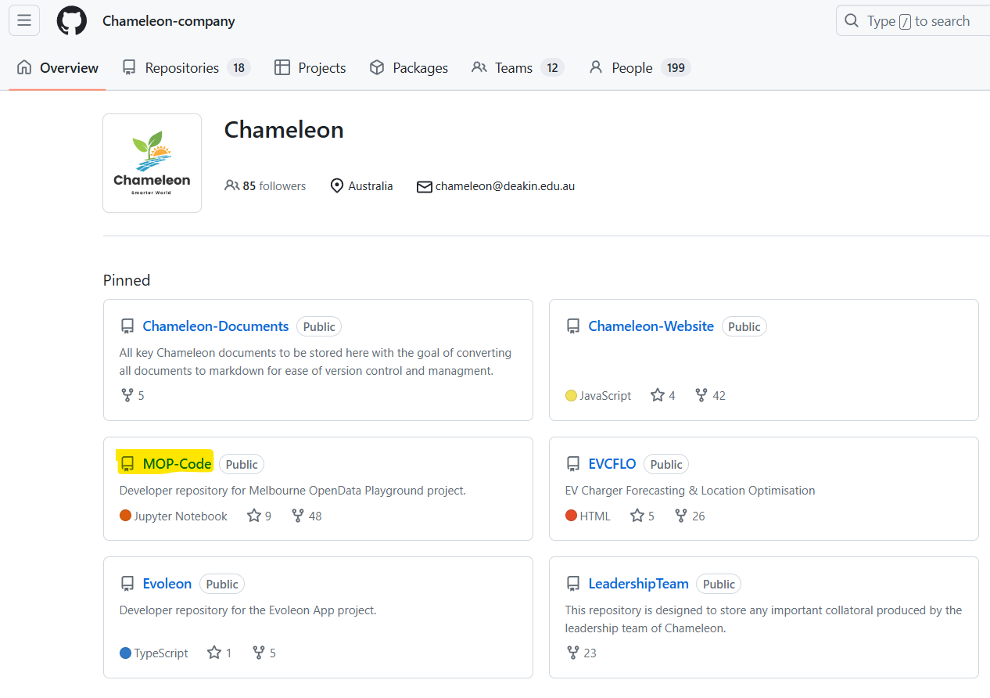

Step 2: Then select branches.
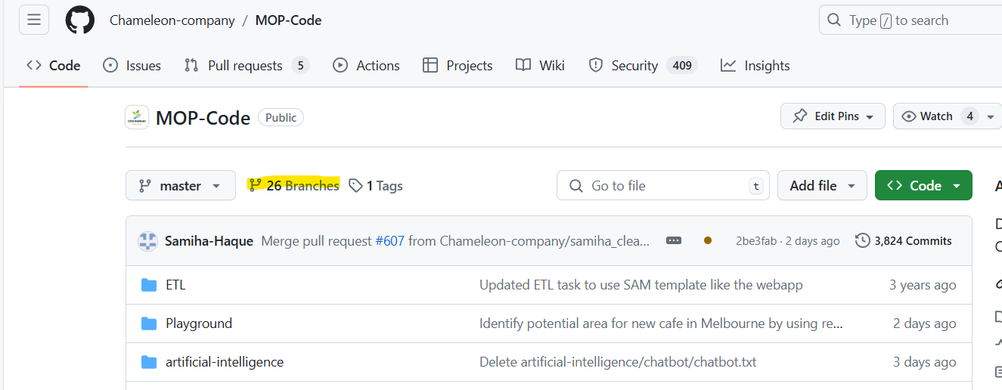

Step 3: Click to create a new branch.
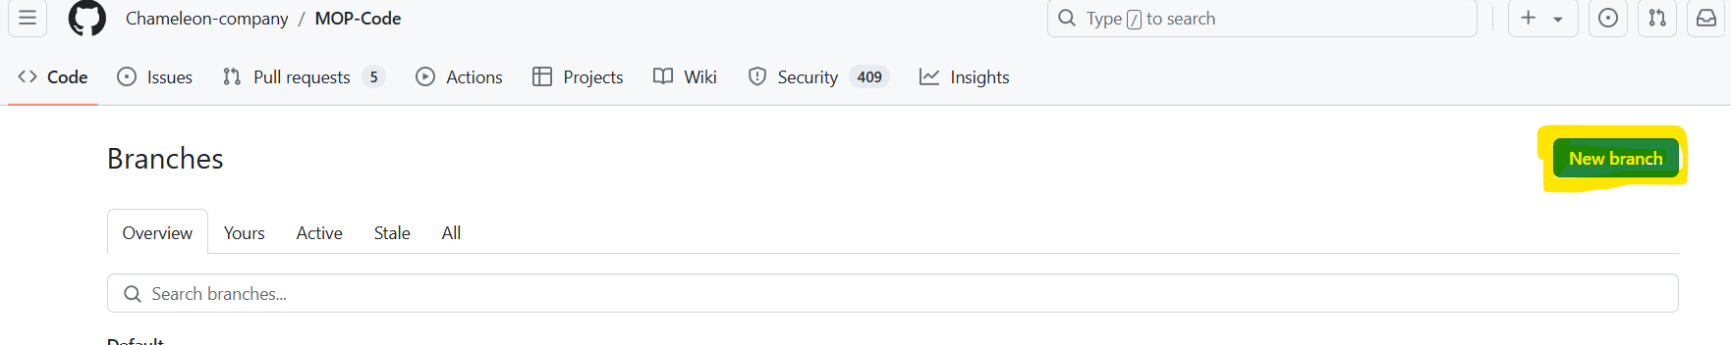
Make sure you copied from the master and give your own branch name and click on create new branch.
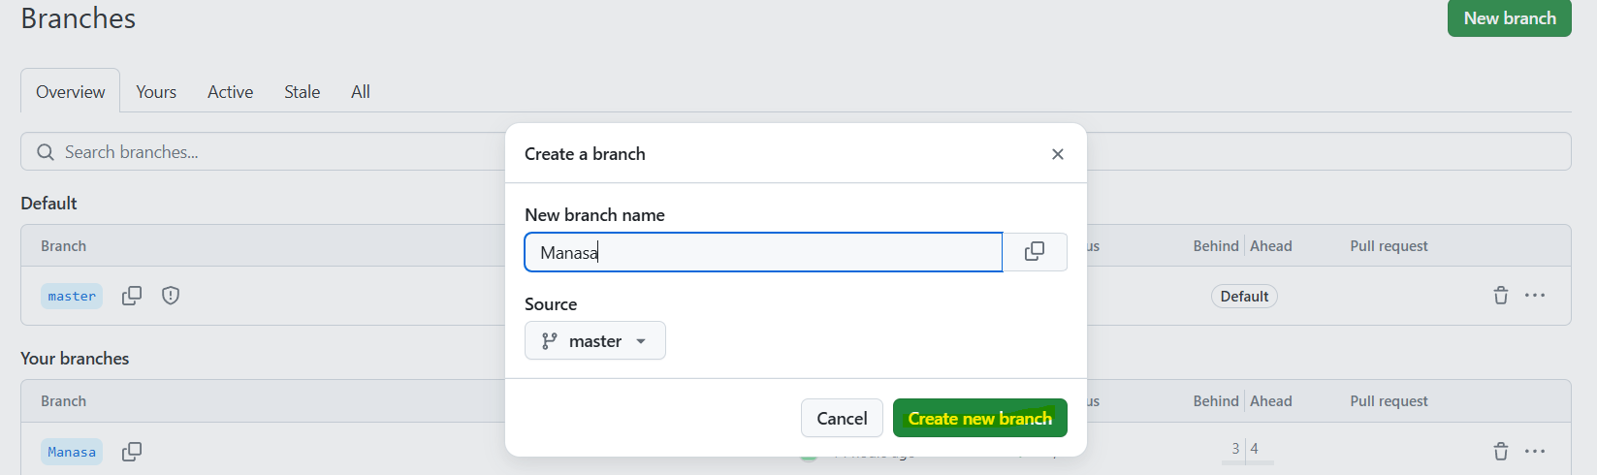

Return to the MOP-Code page and click Code and select the URl
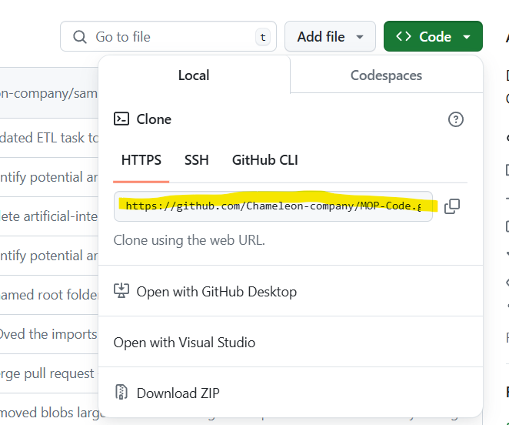

Step 4: Select a local storage location and create a folder . Note: The entire file is 5GB.
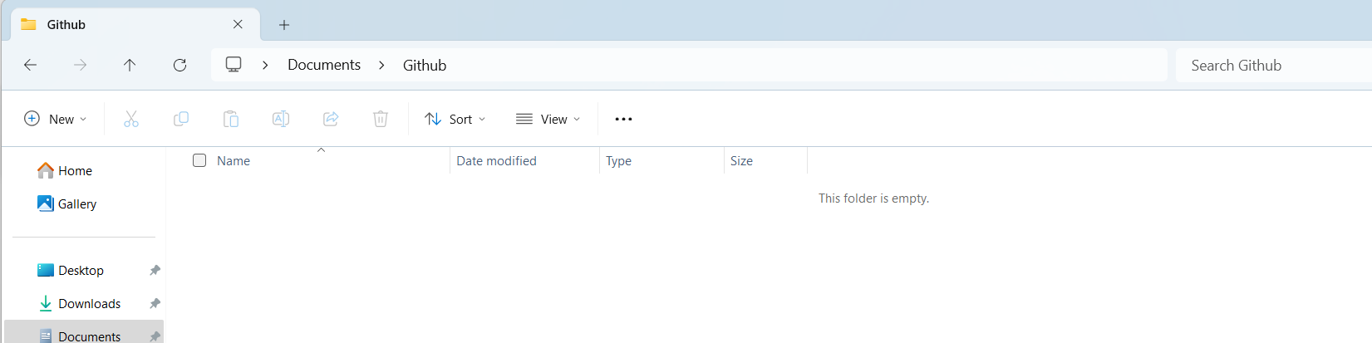
Within the folder select Open with bash here
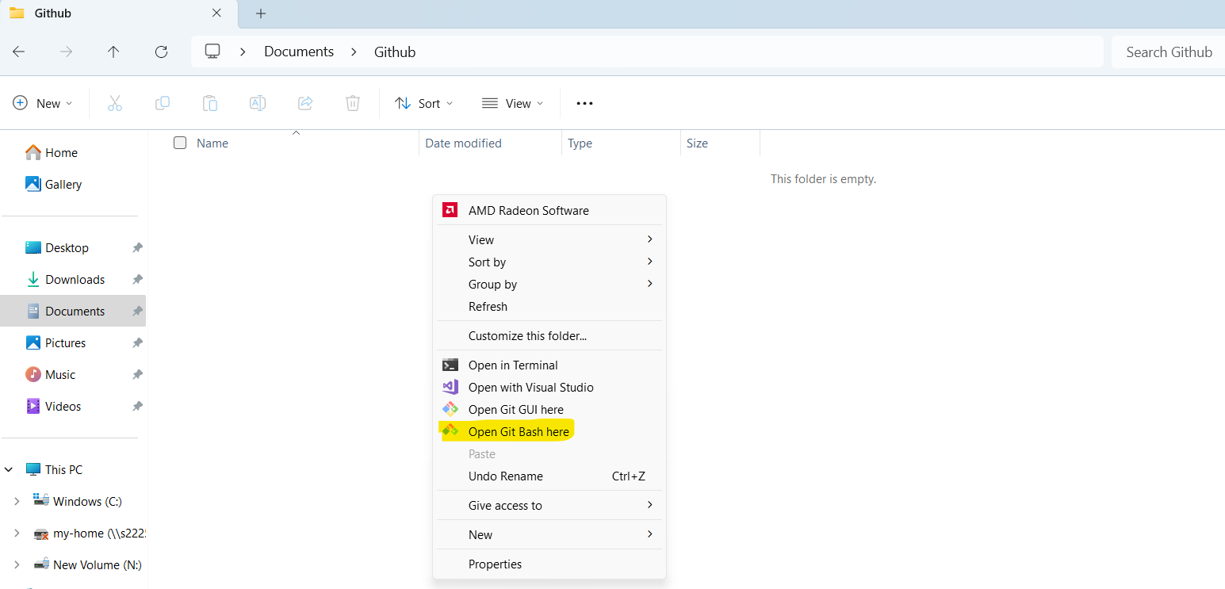

And then type git clone by adding the url coppied from github Code and enter
git clone https://github.com/Chameleon-company/MOP-Code.git

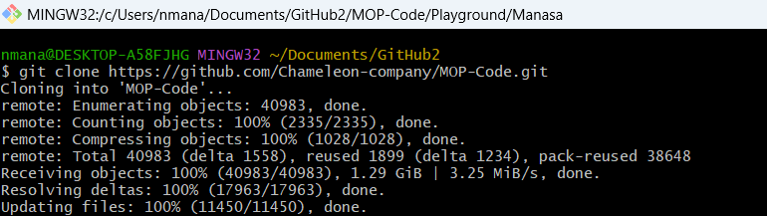

Step 5: After updating the file MOP-Code folder would be created
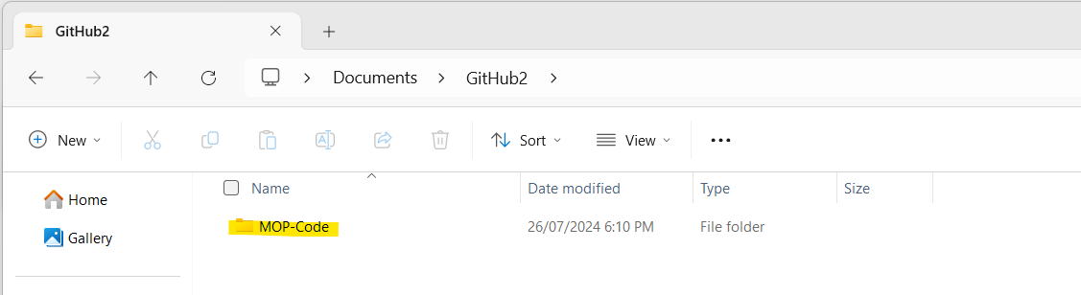
In git bash type cd MOP-Code
And cd Playground

Now we will need to switch from master branch to your branch hence type git check out and type your branch name created in github.
git checkout Manasa
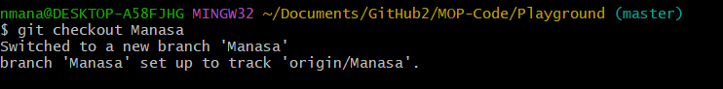
In local storage location now go to MOP – Code Playground
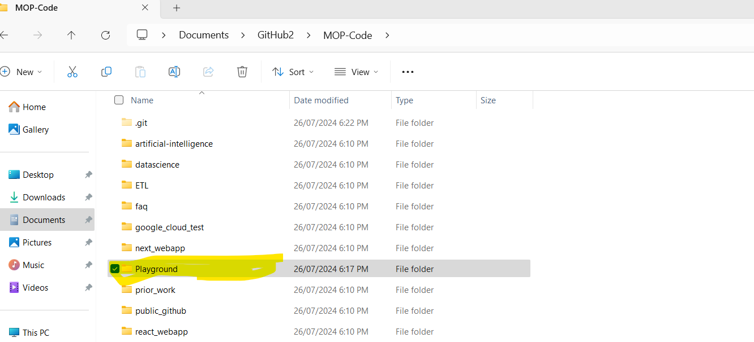

Step 6:Create a folder inside playground.
Note : In the playground folder I have created by my name
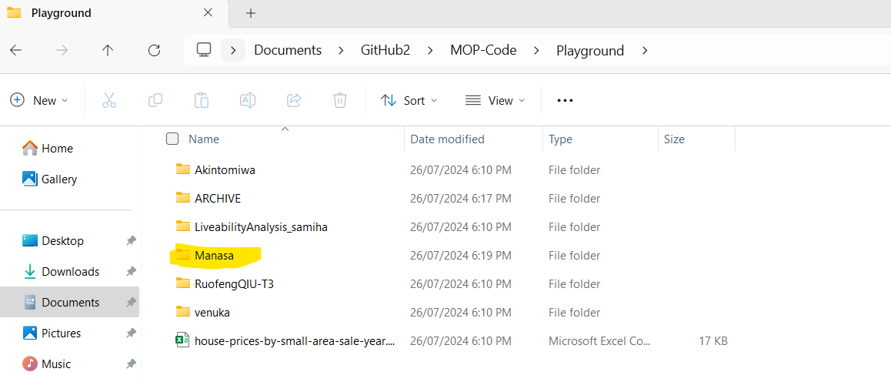

Step 7: Add any test document / Use case template in folder.
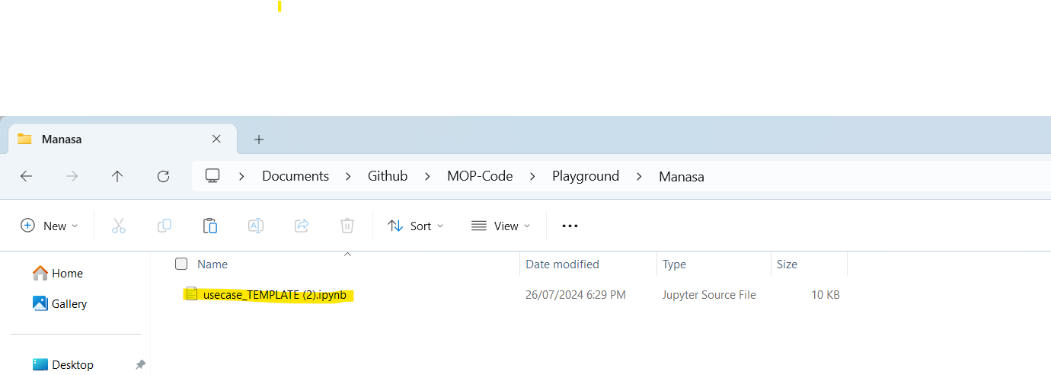

Step8: Open git bash from this folder
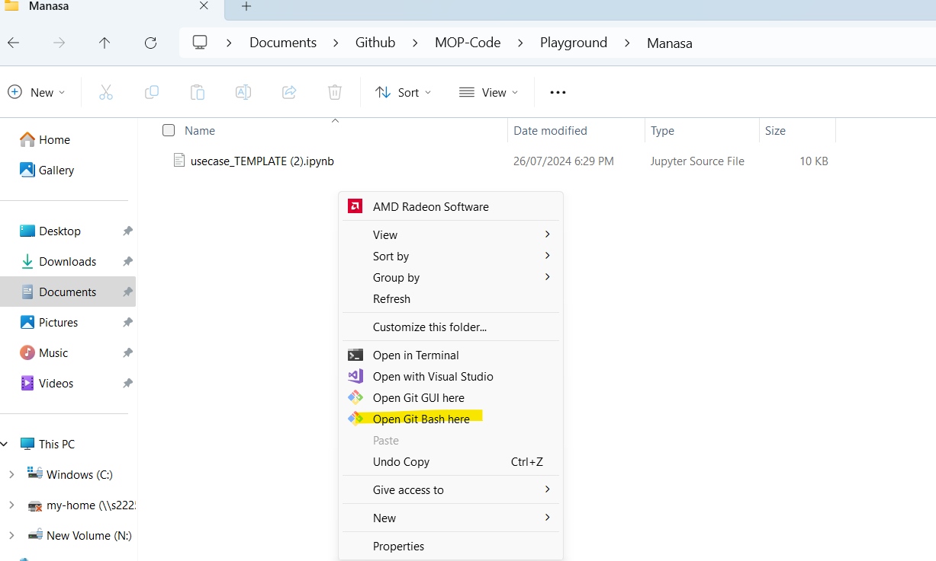
Now type git status
git status
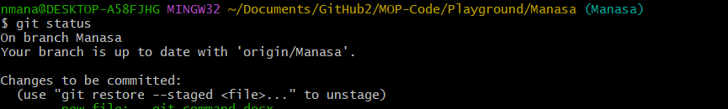
And then type git add . Note: there should be space after add full stop
git add .

And now we are committing the changes by giving command git commit -m “give your message”
git commit -m “adding file”
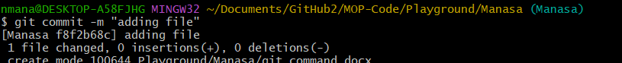

And Type git push to push your changes.

git push
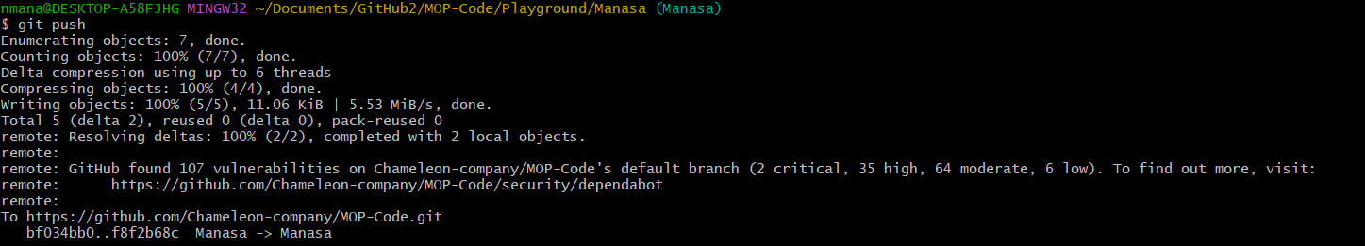
Step 9 : Now we can check in github in our branch, playground folder there would be folder created with the added documents in our local storage.
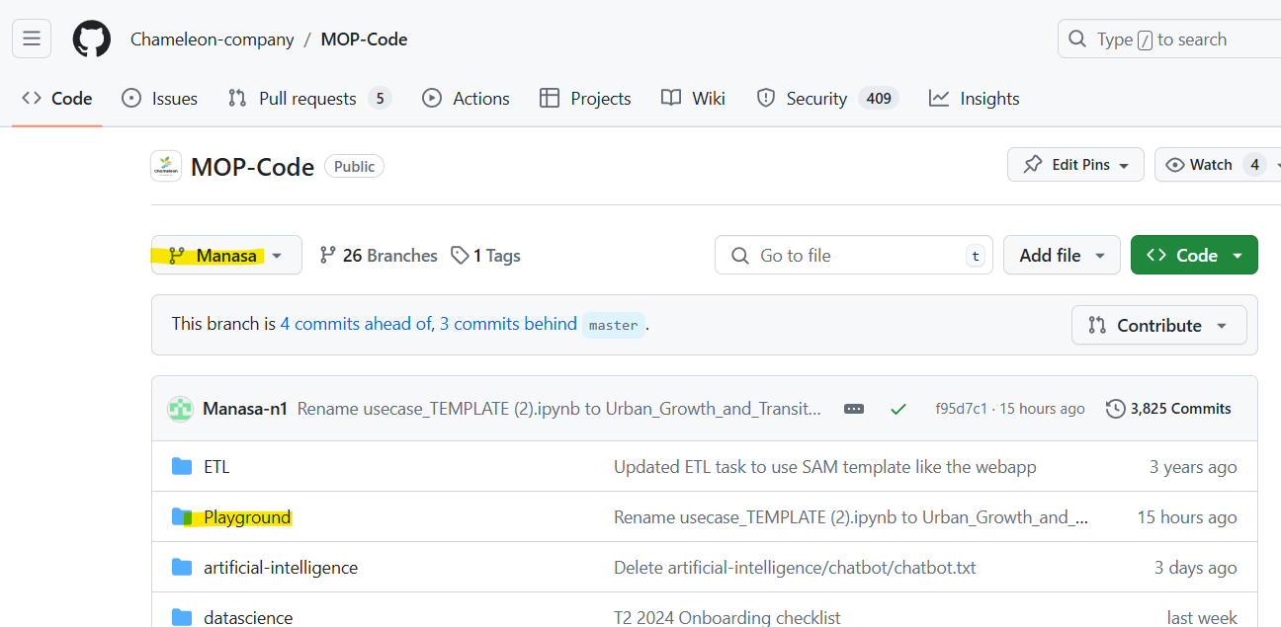
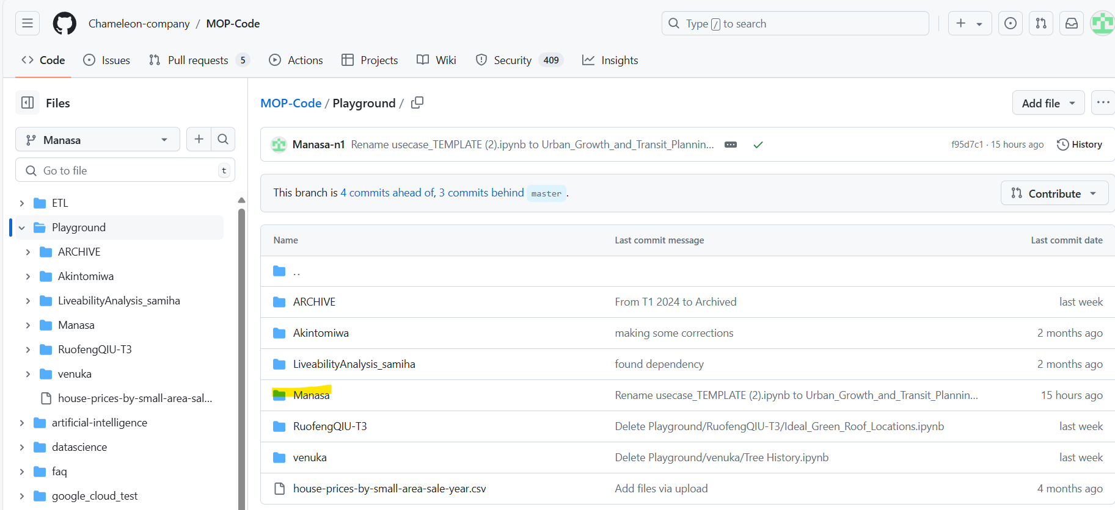

Conclusion
In conclusion, this guide provides a step-by-step process for creating a new branch and folder in a GitHub repository using Git Bash on Windows 10. By following these instructions, users can effectively clone repositories, switch between branches, make local changes, and push updates to GitHub. This ensures seamless collaboration and version control for any project.

Author
Manasa Nagaraja – 2024.v1

